DECEMBER GARDENING CHECKLIST

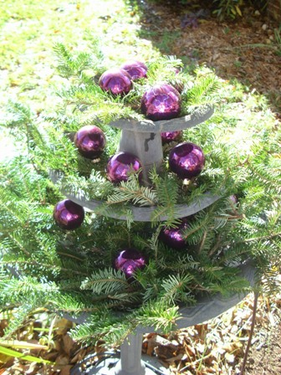

- CLEAN IT UP – Now’s the time to clean up and store your lawn mower and garden tools. If you’re like me, it might be a good time to organize your garage and tools and hang them up!
- RESEED – With the warm fall we’ve had, many flowers are still blooming. Many annual plants reseed (like Zinnia) if you don’t cut back the dying blooms. Allow the seeds to drop and you may experience a “come back” next year.
- REUSE – If you had a fall display that included bales of hay or pine straw, don’t throw them out, use them! Break the bales up and blanket your beds for the winter or use them in a manger scene.
- DECORATE – Holiday decorating easily extends to the garden. Fill your birdbaths or fountains with greenery and bright colored ornaments, use trimmings from your tree to decorate outdoor light fixtures and mailbox. Add lights to your trellis or gazebo’s, outdoor swings and of course, around your front porch.
- TREES—Rosemary trees (often found at home improvement stores this time of year) are a wonderful addition to your holiday décor. They make a fragrant and practical kitchen tree. Decorate with miniature baking items for fun. Water only when the soil is dry to the touch, brown needles indicate over-watering. In the spring you can plant it outdoors.
- LEAVES – Leaves are still falling at my house. Use your lawn mower to mulch the leaves on your lawn instead of trying to catch and bag them.
- HOUSE PLANTS- Continue to force bloom bulbs for floral displays and color during dreary winter days. Poinsettias are a popular indoor holiday plant that is found in grocery stores in reds, greens, and pinks.

